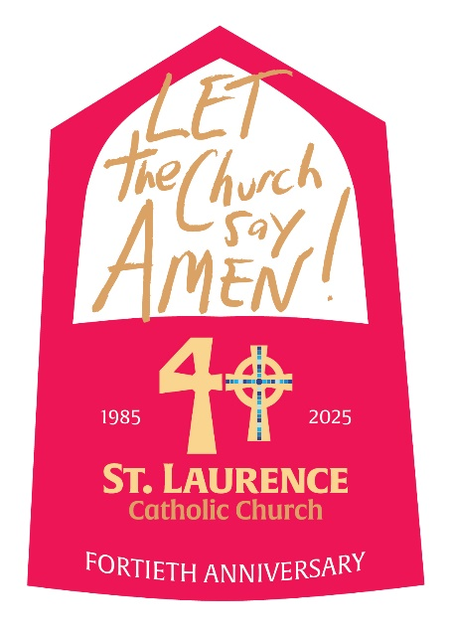

**St. Laurence**

**Celebration of Ministries**

**August 23-24, 2025**

MINISTRY FAIR

* Held in parish hall **following all Masses** August 23-24, 2025
* Approximately 3 feet of table space is assigned to ministries for **a display** (photos, activities, calendar, QR code/sign-up sheet)
* Please **limit the height** of your table display to no more than 3 feet.
* **BYOT** (Bring Your Own Tablecloth/covering)
* Ministries may set up **beginning at 10am on Saturday**
* Schedule reps to be at your display after each Mass
* 3 “I”s – Your reps should always Invite, Include & Inform!
* Pack up and remove your display at 7pm Sunday
* As the ministry leader, contact **that same week** each new person who expressed interest in your ministry to personally welcome them
* On Monday, **email Belinda the total number** of new signups you received
* **Contact:** Belinda Maldonado (bmaldonado@stlaurence.org, 281-980-9812)

PARADE OF MINISTRIES

* Parish ministries represented in the **processional at every Mass**
* 1-2 reps from each ministry **carry a banner**
* Drop off banner **Friday, 8/22,** after 1pm in the Brides room of the church
* **Arrive 20 minutes before Mass** and sign-in in the narthex
* Find your banner (in alpha order) in the Brides Room
* Ministries **process down center aisle** and span length of sanctuary
* Clergy follows and offers a blessing over the assembled ministries
* **NEW:** Ministries exit up the side aisles and drop banners off in narthex
* **Contact:** Roxie Casal, 931-349-8301, roczi33@yahoo.com

LAY WITNESS SPEAKERS

* A Lay Witness Speaker will **speak at the conclusion of each Mass**
* The speaker will share his/her own story about growing in faith through parish ministry
* Concludes with an invitation to attend the Ministry Fair in the parish hall

BE THE LIGHT AWARD

* Awarded by the Discipleship Council to the **ministry that best exemplifies discipleship and hospitality during the Celebration of Ministries Weekend**
* Considered: representation in the Parade of Ministries, welcoming volunteers at the Ministry Fair, thoughtful Ministry Fair display with informative handouts, number of sign-ups, timely follow-up, extra service offered during Celebration of Ministries weekend
* **Traveling trophy** is engraved with the name of the ministry
* Displayed throughout the year on the Hospitality Desk in the narthex of the church